**A Project Report on**

# RESUME(PROFILE)

**USING HTML & CSS**

submitted by

**APARNA SANA- GQT-S0170**

under the mentorship of

# KESHAV MURTHY



**GLOBAL QUEST TECHNOLOGIES**

info@gqtech.in

Yelahanka Satellite Town,

Bangalore, Karnataka - 560064.

[2023]

## Signature of the mentor Signature

**Keshav G.R.Narendra Reddy**

**INTRODUCTION**

**HISTORY OF HTML:**

**HTML** stands for **Hyper Text Markup Language**.

* It is used to share the information over the internet.
* HTML id developed by Tim Berner’s Lee in 1991.But officially in 1993.
* The First version of HTML consists of “18 tags”
* HTML follows certain rules and regulations setup by “**ISO**”.
* International Organization for standardization is set of rules and regulation are present in ‘**SGML**’ document.

## Versions of HTML

* **HTML-1** version in the year 1993.
* **Html-2** version in the year 1995.
* **HTML-3.02** version in the year 1997.
* **HTML-4.1** version in the year 1999.
* **HTML-5** version in the year 2014.

## Features of HTML

* It is easy to Learn.
* It is a tag based language.
* HTML is supported by multiple browsers.
* First web browser is Netscape navigation which was developed by the “Mosiac”.
* It is a portable language.
* **WORA** stands for ‘write once run anywhere’

## Limitation of HTML

* HTML has less designing capabilities.
* It is dependent on other technology such as CSS in order to develop well designed Webpages.
* HTML has no programming capabilities.
* Using HTML and CSS we can develop only static Web page.
* In order to write the HTML code required an editor such as VS Code, Notepad, Eclipse.
* In order to execute the HTML code we required Web browsers.Like Chrome, Firefox, edge, Opera Safari .

## CSS

* **CSS** stands for **Cascading Style Sheets**.
* It was developed by W3C to add stylings to the HTML elements.
* W3C stands for World Wide Web.com **Versions of CSS:**
* CSS-1 (level-1) in the year 1996.
* CSS-2 (level-2) in the year 1998.
* CSS-3 (level-3) in the year 1999.

**Why do we required CSS ?**

* Since HTML has less designing capabilities we cannot create well designed or most appealing Websites.
* Using HTML we cannot add style, animation and transitions to the Webpage.
* Therefore we require CSS to create well designed Webpages.

### Advantages of CSS

* It allows to add styles, animation and variouses effects to the Webpage.
* It allows us to develop the Webpage rapidly. It is also know as RAD ( rapid application Developer).
* It allows us to separate from formatting develop page to the presentation of Webpage.
* It allows to create well designed Websites.

### Limitations of CSS

* Using CSS we can perform static styles for the Webpages.
* In order to create dynamic styling for the Websites. We must make use of scripting language such as JavaScript and Libraries of JavaScript.

**Types of CSS:**

1. Inline CSS
2. Internal CSS
3. External CSS
4. Default Browser CSS **Inline CSS:**

Defining all the CSS properties within the style attribute inside the opening of the tag is referred to as Inline CSS.

**Internal CSS:**

Defining all the CSS properties within <style> inside the HTML document is referred to as Internal CSS.

**External CSS:**

Defining all the CSS properties within as external Script or File with an extension CSS is referred to as External CSS.

* In order to link external CSS file within the HTML document we must use of <link>.
* The value for the ‘ref’ attribute should be ‘stylesheet’.

**PROJECT:**

**ROOT STRUCTURE:**

HTML AND CSS FILES

→APARNA RESUME.HTML

→APARNA RESUME.CSS

PROJECT REPORT

→APARNA RESUME.DOC

SCREENSHOTS

→ALL THE REQUIRED SCREENSHOTS

**CONTROL FLOW DIAGRAM:**

MY RESUME2.HTMLIS OPENED

CLICK

# RESUME(PROFILE)

## Scope of the document

I was created Resume using HTML & CSS.The Scope of the document is:

**Personal Information:** It includes my name, contact information, and a professional summary or objective statement.

**Education:**I have Listed my educational background, including institutions attended, degrees earned, and relevant dates.

**Skills:** I have mentioned technical and soft skills in a clear and organized manner.

**Projects:** I have done two projects in my college, that is also mentioned in this resume.

**Achievements and Awards:** I have completed some courses in online platform i.e Hackerrank.

**Certifications:** I achieved few cirtificates during my college and internships thoes are mentioned in this resume.

**Design and Styling:** Implemented my resume using HTML and CSS skills to design a visually appealing and well-structured resume.

## Technologies Used

* HTML5
* CSS3

**Our Project Source Code:-**

**Resume.html:**

<!DOCTYPE html>

<html lang="en">

<head>

<meta charset="UTF-8">

<meta name="viewport" content="width=device-width, initial-scale=1.0">

<title>MY RESUME</title>

<link rel="stylesheet" href="myresume2.css">

<link rel="stylesheet" href="https://cdnjs.cloudflare.com/ajax/libs/font-awesome/4.7.0/css/font-awesome.min.css">

</head>

<body>

<div class="main">

<div class="top-section">

<img src="resume pic.jpeg" class="profile">

<p class="p1">APARNA &nbsp;SANA</p>

</div>

<div class="class1">

<div class="class2">

<div class="content-box" style="padding-left: 40px;">

<p class="head" style="font-size: 20px;color: orange;text-transform: uppercase;font-weight: 600;">Skills</p>

<ul>

<li><span>HTML-5</span></li>

<li><span>CSS-3</span></li>

<li><span>Manual Testing</span></li>

<li><span>Java</span></li>

<li><span>Python</span></li>

</ul>

<br/>

<p class="head" style="font-size: 20px;color: orange;text-transform: uppercase;font-weight: 600;">Languages</p>

<p class="p3" style="margin-left: 20px;">Telugu</p>

<p class="p3" style="margin-left: 20px;">English</p>

<p class="p3" style="margin-left: 20px;">Hindi</p>

<br/>

<p class="head" style="font-size: 20px;color: orange;text-transform: uppercase;font-weight: 600;">interests</p>

<ul>

<li><span>Designing Websites</span></li>

<li><span>Machine Learning</span></li>

</ul>

</div>

<br/>

<p class="head" style="font-size: 20px;color: orange;text-transform: uppercase;font-weight: 600;margin-left: 36px;">Contact</p>

<p class="p3">&nbsp;&nbsp;&nbsp;&nbsp;<i class="fa fa-phone" style="margin-left: 17px;"></i>&nbsp;&nbsp;9391320341</p>

<p class="p3">&nbsp;&nbsp;&nbsp;&nbsp;<i class="fa fa-envelope" style="margin-left: 17px;"></i>&nbsp;&nbsp;aparnassana2001@gmail.com</p>

<p class="p3">&nbsp;&nbsp;&nbsp;&nbsp;<i class="fa fa-home" style="margin-left: 17px;" ></i>&nbsp;&nbsp;kukkalagunta,Rajendra Nagar,<br>&nbsp;&nbsp;&nbsp;&nbsp;&nbsp;&nbsp;&nbsp;&nbsp;&nbsp;&nbsp;&nbsp;&nbsp;Nellore 524001.</p>

</div>

<div class="line">

</div>

<div class="class3">

<div class="content-box">

<p class="head" style="font-size: 20px;color: orange;text-transform: uppercase;font-weight: 600;">objective</p>

<p class="p3">To secure a responsible career opportunity to fully utilize my training and skills, while making a significant contribution

to the success of the company</p>

<br/>

<p class="head" style="font-size: 20px;color: orange;text-transform: uppercase;font-weight: 600;">internship</p>

<p class="p3">Done Internship succesfully completing AWS Cloud Virtual Internship during sep-oct 2022

supported by AWS ACADEMY on Eduskills.</p>

<h4><u>Intern:</u></p></h4>

<ul type="square">

<li ><span>During Internship I create an virtual machine in the Amazon Cloud.Using AWS Management Console I launch an EC2 instance

and also provide the Virtual Private Cloud(VPC) and Security groups.</span></li>

<li ><span>I create an Amazon EBS volume and attached to that EC2 instance.</span></li>

<li ><span>I create an bucket for my instance using Amazon S3 console.</span></li>

<li ><span>In intern I done all the badges on basis of AWS Cloud Foundations.</span></li>

</ul>

<br/>

<p class="head" style="font-size: 20px;color: orange;text-transform: uppercase;font-weight: 600;">certificate</p>

<p class="p3">Certification of course completion for succesfully completing AMAZON WEB SERVICES CLOUD FOUNDATIONS from

01 September 2022 to 30 November 2022 by AWS Academy on Eduskills.</p>

<br/>

<p class="head" style="font-size: 20px;color: orange;text-transform: uppercase;font-weight: 600;">education</p>

<ul>

<li ><span>Completed Bachelor degree on BCA at Krishna Chaithanya degree college with an aggregate of 95% in 2023.</span></li>

<li ><span>Completed Intermediate from Rao's Junior College with 9.8GPA in 2019.</span></li>

<li ><span>Completed SSC from Government Model High School with 9.3GPA in 2017.</span></li>

</ul>

</div>

</div>

</div>

</div>

</body>

</html>

**Output:**

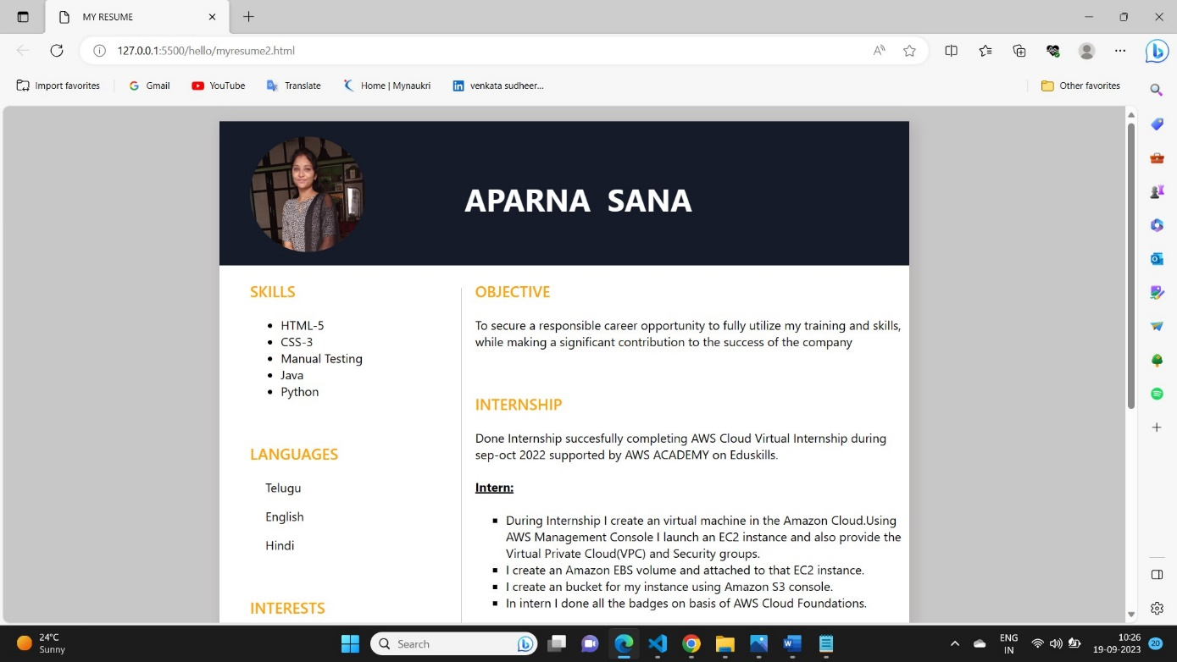

Fig:1

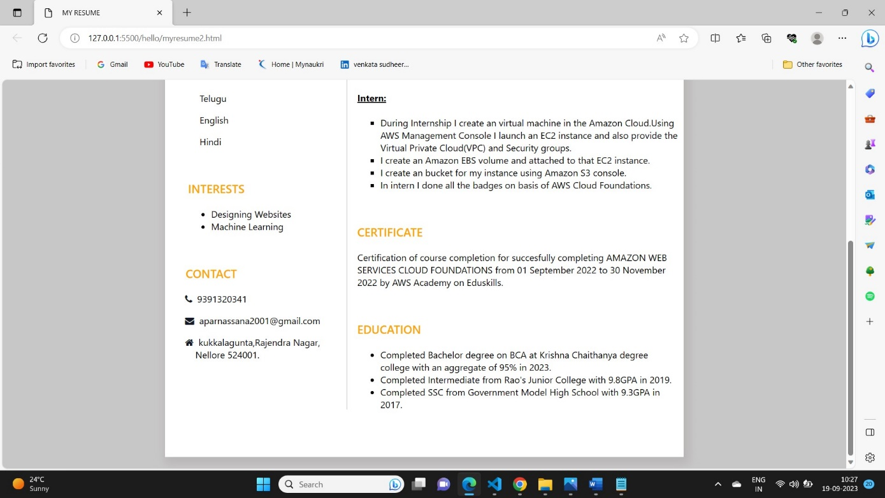

Fig:1.2

**Conclusion**

"In crafting this resume using HTML and CSS, I aimed to create a professional and visually engaging representation of my qualifications and experiences. With a strong educational background, a proven track record in [Computer science and Engineering], and a diverse skill set that includes [Java fullstack Development, HTML,CSS,Java Script,MySql].

This resume serves as a snapshot of my journey and abilities, and I am ready to provide more detailed information and discuss how I can add value to your organization.